IT24103496

WELIANGA L.D.L

1.

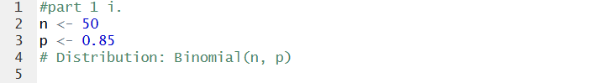

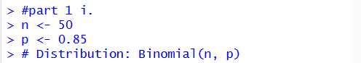

**2.**

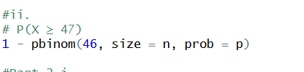

**Part 2**

**1.**

**2.**

**3.**

